Locating Riyadh Residential Areas which lack for Public Library

By: Eng. Mohammed Alqahtany

Geospatial Engineer

The Goal from this Project is to help me locate which residential areas in my city lack for Public Library within 20 minutes drive

First: I will start my analysis with Spatial statistical analysis Tools , They give me big picture for my study

Beginning with Mean Center Tool , this tool helps me to identify the centered library which is the Jarir Bookstore Olaya Branch, it is located exactly in the center of the libraries, see the green circle below .

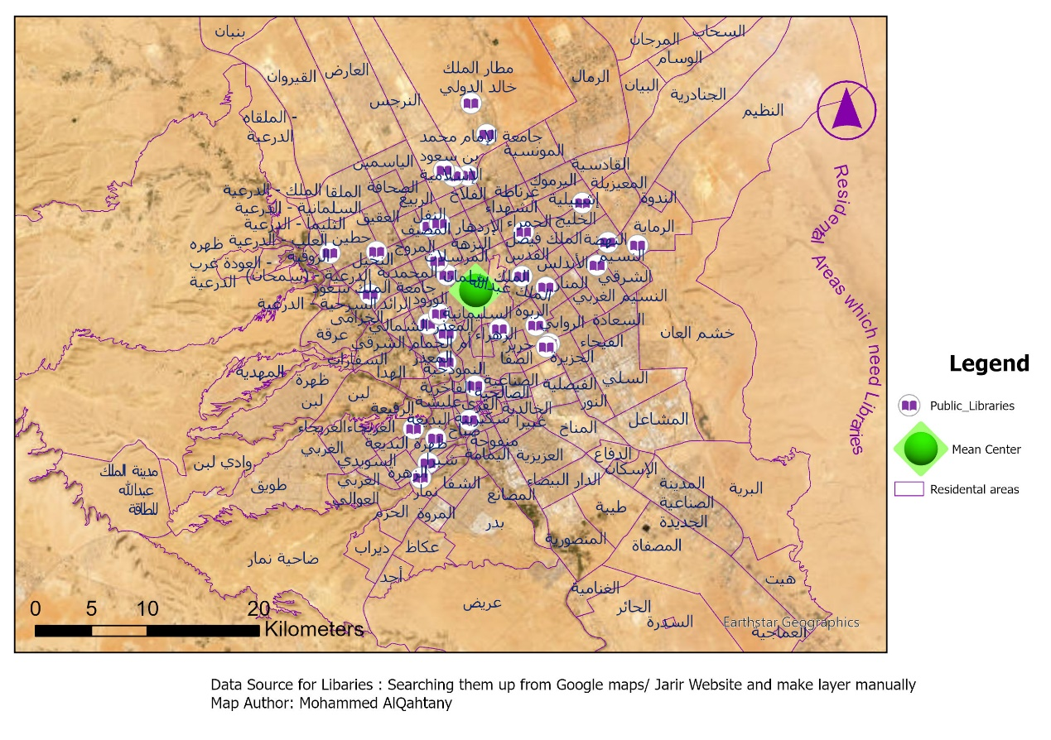

صورة تحتوي على نص, خريطة, أطلس, لقطة شاشة

تم إنشاء الوصف تلقائياً

Then I want to to identify the spread of the Libraries around the centered library is it too much or little , also how about outside the circle created by Standard distance tool ,Are there too much or little libraries . see fig. below:صورة تحتوي على نص, خريطة, أطلس, لقطة شاشة

تم إنشاء الوصف تلقائياً

I can confirm now , most of libraries are within the Mean Center circle radius of 10.3 km(see the blue circle above) =meaning other than centered residental areas , there are only few libraries! Which is not a good indicator

Next I would like to specify the direction of the libraries distribution to help me understand my analysis more and see on which direction is it spreading. See fig. below:

صورة تحتوي على نص, خريطة, أطلس, لقطة شاشة

تم إنشاء الوصف تلقائياً

Second:

I will use Network analysis , This analysis is complex and very accurate!

I want to identify which Residental Areas lack for libraries by calculating 10/20/30 minutes drive from Neighbourhoods to Libraries.

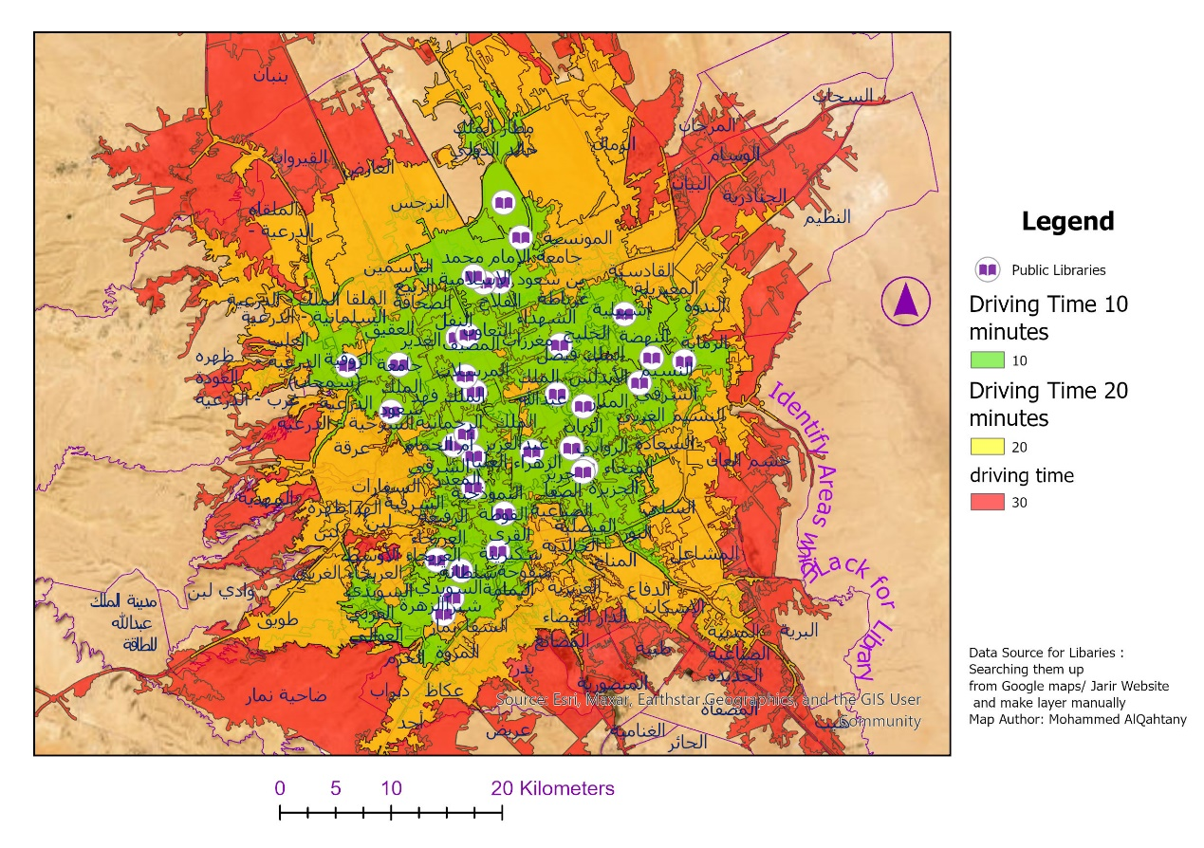

The Green Color Polygon Shown Above indicate the areas don't need library , as it needs only 10 minutes from from surroundings towards the library, while The Yellow Color Polygon indicates that from this Polygon it takes 20 minutes drive towards the nearest Public Library, Hence we need to build public library for their own, The need to build library is bigger in the Red Color Polygon as it indicates the Red Area takes 30 mintes driving time to reach to nearest public library.

This is the attribute table shows the libraries I look up from Google maps and Jarir bookstore website and I add them manually in my GDB:

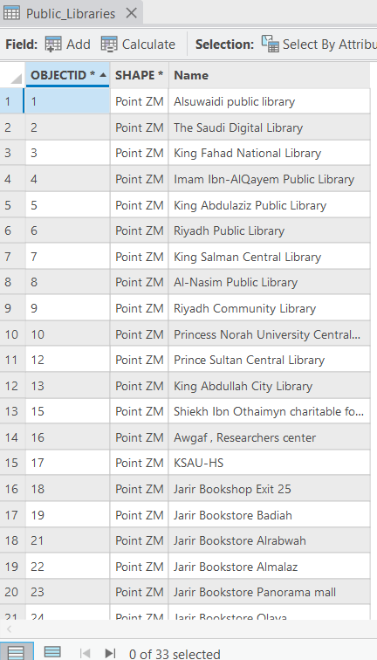

صورة تحتوي على نص, لقطة شاشة, رقم, الخط

تم إنشاء الوصف تلقائياً

My Recommendations :-Build More Public Libraries in the Areas lack for libraries, As this analysis clearly shows how lack we are for public libraries